**Kathmandu University**

**Department of Computer Science and Engineering**

**Dhulikhel, Kavre**



**Lab Report III**

**[COMP 342]**

**Submitted by:**

Abhijeet Poudel

CS(III/I)

Roll No: 44

**Submitted to:**

Mr. Dhiraj Shrestha

**Department of Computer Science and Engineering**

**Submission Date: 18th December 2022**

**Table of Contents**

Chapter 1: Introduction 4

Chapter 2: The Two-Dimensional Object and Preliminaries 4

Chapter 3: 2D Translation 5

3.1. Translation Matrix 5

3.2. Source Code 6

3.3 Output 9

3.3.1. Original Triangle 9

3.3.2. Triangle after translation of 0.5 9

Chapter 4: 2D Rotation 10

4.1. Rotation Matrix 10

4.2. Source Code 10

4.3. Output 13

4.3.1. Original Triangle 13

4.3.2. Triangle after Rotation by 45 degree 13

Chapter 5: 2D Scaling 14

5.1. Scaling Matrix 14

5.2. Source Code 15

5.3. Output 17

5.3.1. Original Triangle 17

5.3.2. Scaled Triangle with scaling factor 1.5 18

5.3.3. Scaled Triangle with Scaling factor 1.5 along x-axis 19

5.3.4. Scaled Triangle with Scaling factor 1.5 along y-axis 19

Chapter 6: Reflection on 2D Objects 20

6.1. Reflection Matrix 20

6.2. Source Code 20

6.3. Output 23

6.3.1. Original Triangle 23

6.3.2. Reflection about x-axis 23

6.3.2. Reflection about y-axis 23

Chapter 7: 2D Shearing 24

7.1. Shearing Matrix 24

7.2. Source Code 25

7.3. Output 28

7.3.1. Original Triangle 28

7.3.2. Triangle sheared on x-axis 28

7.3.3. Triangle sheared along y-axis 29

Chapter 8: Conclusion 30

# Chapter 1: Introduction

For our lab work and project, the following programming language and tools are used:

**Graphics Library:** PyOpenGL 3.1.6

**Programming Language:** Python 3.10.5

**Window Context:** GLFW

**Helpers:** Numpy

# Chapter 2: The Two-Dimensional Object and Preliminaries

The two-dimensional object that we will be using for this demonstration is a simple triangle that is drawn with the help of the primitive GL_TRIANGLES.

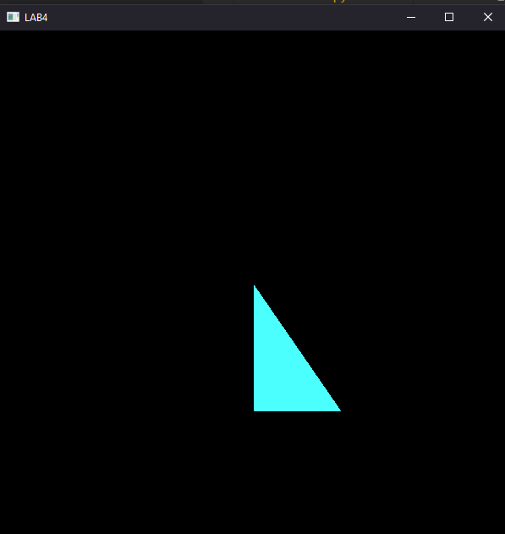

We will use a 4 by 4 homogenous matrix to translate the points of the two-dimensional object and hence, set the value of the z to 0 and proceed normally i.e., generate a 4x4 translation matrix and multiply the matrix with the vertices of the object, a triangle in this case. We will multiply the generated transformation matrix with the object vertices inside the vertex shader and fragment as follows:

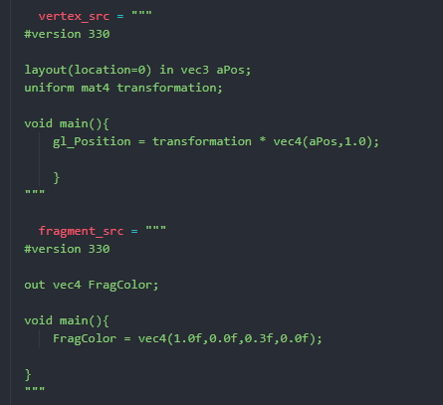

Here, the transform matrix is multiplied with the 2D object which has also been made into a 4D matrix by setting the z axis to 0

# Chapter 3: 2D Translation

## 3.1. Translation Matrix

In order to translate any 2D object the matrix to be used is:

|  |  |  |  |
| --- | --- | --- | --- |
| 1 | 0 | 0 | Tx |
| 0 | 1 | 0 | Ty |
| 0 | 0 | 1 | 0 |
| 0 | 0 | 0 | 1 |

Since, this is a 2D object the translation in z axis is set to 0. Furthermore, the vertex shader performs matrix multiplications in column major basis but the normal translation matrix is row major matrix so firstly the above matrix is to be transposed as:

|  |  |  |  |
| --- | --- | --- | --- |
| 1 | 0 | 0 | 0 |
| 0 | 1 | 0 | 0 |
| 0 | 0 | 1 | 0 |
| Tx | Ty | 0 | 1 |

Now, using this matrix any 2D object can be easily translated by the given factor.

## 3.2. Source Code

*import* glfw

*import* numpy *as* np

*from* OpenGL.GL *import* *

*from* OpenGL.GL.shaders *import* compileProgram, compileShader

*from* helpers *import* **altList**, **toNVC**

def **window_resize**(*window*, *width*, *height*):

    glViewport(0, 0, *width*, *height*)

RESOLUTION = 800

*#translation matrix with tx=ty=0.5*

translation = np.**array**(

    [

        1.0,0.0,0.0,0.0,

        0.0,1.0,0.0,0.0,

        0.0,0.0,1.0,0.0,

        0.5,0.5,0.0,1.0,

    ],

*dtype*=np.float32,

)

def **main**(*transformation*):

    vertex_src = """

  #version 330

  layout(location=0) in vec3 aPos;

  uniform mat4 transform;

  void main(){

      gl_Position = transform * vec4(aPos,1.0);

      }

  """

    fragment_src = """

  #version 330

  out vec4 FragColor;

  void main(){

      FragColor = vec4(1.0f,0.0f,0.3f,0.0f);

  }

  """

*if* *not* glfw.init():

*raise* Exception("glfw can not be initialized!")

    window = glfw.create_window(RESOLUTION, RESOLUTION, "LAB4", None, None)

*if* *not* window:

        glfw.terminate()

*raise* Exception("glfw window can not be created!")

    glfw.set_window_pos(window, 100, 100)

    glfw.set_window_size_callback(window, **window_resize**)

    glfw.make_context_current(window)

    vertices = [

        -0.27390625,

        0.19890625000000003,

        0,

        -0.27390625,

        -0.4223437499999999,

        0,

        0.34421874999999985,

        -0.4223437499999999,

        0,

    ]

    vertices = np.**array**(vertices, *dtype*=np.float32)

    indices = [1, 2, 3]

    indices = np.**array**(indices, *dtype*=np.uint32)

    shader = compileProgram(

        compileShader(vertex_src, GL_VERTEX_SHADER),

        compileShader(fragment_src, GL_FRAGMENT_SHADER),

    )

    vertex_buffer_object = glGenBuffers(1)

    glBindBuffer(GL_ARRAY_BUFFER, vertex_buffer_object)

    glBufferData(GL_ARRAY_BUFFER, vertices.nbytes, vertices, GL_STREAM_DRAW)

    element_buffer_object = glGenBuffers(1)

    glBindBuffer(GL_ELEMENT_ARRAY_BUFFER, element_buffer_object)

    glBufferData(GL_ELEMENT_ARRAY_BUFFER, indices.nbytes, indices,

                 GL_STREAM_DRAW)

    glEnableVertexAttribArray(0)

    glVertexAttribPointer(0, 3, GL_FLOAT, GL_FALSE, 0, ctypes.c_void_p(0))

    glUseProgram(shader)

    transformation_location = glGetUniformLocation(shader, "transformation")

*while* *not* glfw.window_should_close(window):

        glfw.poll_events()

        glUniformMatrix4fv(transformation_location, 1, GL_FALSE,

*transformation*)

        glDrawElements(GL_TRIANGLES, **len**(indices), GL_UNSIGNED_INT, None)

        glfw.swap_buffers(window)

    glfw.terminate()

**main**(translation)

## 3.3 **Output**

### 3.3.1. Original Triangle



### 3.3.2. Triangle after translation of 0.5

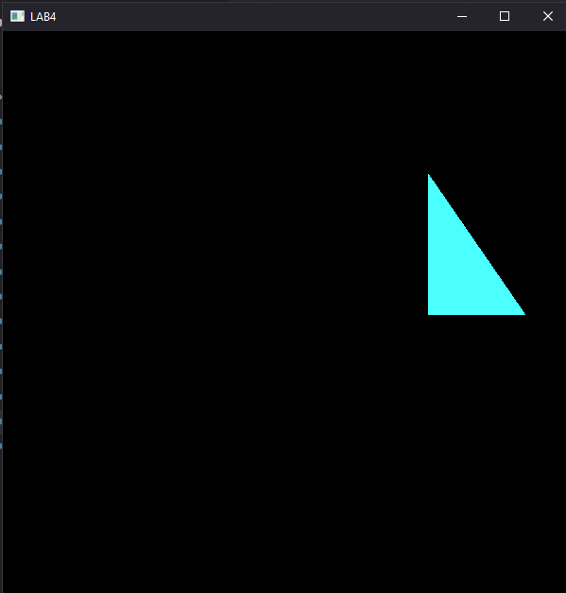

# Chapter 4: 2D Rotation

## 4.1. Rotation Matrix

The rotation matrix for 2D is:

|  |  |  |  |
| --- | --- | --- | --- |
| cos(θ) | -sin(θ) | 0 | 0 |
| sin(θ) | cos(θ) | 0 | 0 |
| 0 | 0 | 1 | 0 |
| 0 | 0 | 0 | 1 |

However, as this matrix is row major and vertex shader calculates matrix multiplication in column major basis, we have to transform the above matrix as:

|  |  |  |  |
| --- | --- | --- | --- |
| cos(θ) | sin(θ) | 0 | 0 |
| -sin(θ) | cos(θ) | 0 | 0 |
| 0 | 0 | 1 | 0 |
| 0 | 0 | 0 | 1 |

Now using this matrix, we can rotate any 2D object.

## 4.2. Source Code

*import* glfw

*import* numpy *as* np

*from* OpenGL.GL *import* *

*from* OpenGL.GL.shaders *import* compileProgram, compileShader

*from* helpers *import* **altList**, **toNVC**

def **window_resize**(*window*, *width*, *height*):

    glViewport(0, 0, *width*, *height*)

RESOLUTION = 800

rotation = np.**array**(

    [

        np.cos((np.pi / 180) * 45),  *# D1*

        np.sin((np.pi / 180) * 45),

        0.0,

        0.0,

        np.sin(-(np.pi / 180) * 45),

        np.cos((np.pi / 180) * 45),  *# D2*

        0.0,

        0.0,

        0.0,

        0.0,

        1.0,

        0.0,

        0.0,

        0.0,

        0.0,

        1.0,

    ],

*dtype*=np.float32,

)

def **main**(*transformation*):

    vertex_src = """

  #version 330

  layout(location=0) in vec3 aPos;

  uniform mat4 transform;

  void main(){

      gl_Position = transform * vec4(aPos,1.0);

      }

  """

    fragment_src = """

  #version 330

  out vec4 FragColor;

  void main(){

      FragColor = vec4(1.0f,0.0f,0.3f,0.0f);

  }

  """

*if* *not* glfw.init():

*raise* Exception("glfw can not be initialized!")

    window = glfw.create_window(RESOLUTION, RESOLUTION, "LAB4", None, None)

*if* *not* window:

        glfw.terminate()

*raise* Exception("glfw window can not be created!")

    glfw.set_window_pos(window, 100, 100)

    glfw.set_window_size_callback(window, **window_resize**)

    glfw.make_context_current(window)

    vertices = [

        -0.27390625,

        0.19890625000000003,

        0,

        -0.27390625,

        -0.4223437499999999,

        0,

        0.34421874999999985,

        -0.4223437499999999,

        0,

    ]

    vertices = np.**array**(vertices, *dtype*=np.float32)

    indices = [1, 2, 3]

    indices = np.**array**(indices, *dtype*=np.uint32)

    shader = compileProgram(

        compileShader(vertex_src, GL_VERTEX_SHADER),

        compileShader(fragment_src, GL_FRAGMENT_SHADER),

    )

    vertex_buffer_object = glGenBuffers(1)

    glBindBuffer(GL_ARRAY_BUFFER, vertex_buffer_object)

    glBufferData(GL_ARRAY_BUFFER, vertices.nbytes, vertices, GL_STREAM_DRAW)

    element_buffer_object = glGenBuffers(1)

    glBindBuffer(GL_ELEMENT_ARRAY_BUFFER, element_buffer_object)

    glBufferData(GL_ELEMENT_ARRAY_BUFFER, indices.nbytes, indices,

                 GL_STREAM_DRAW)

    glEnableVertexAttribArray(0)

    glVertexAttribPointer(0, 3, GL_FLOAT, GL_FALSE, 0, ctypes.c_void_p(0))

    glUseProgram(shader)

    transformation_location = glGetUniformLocation(shader, "transformation")

*while* *not* glfw.window_should_close(window):

        glfw.poll_events()

        glUniformMatrix4fv(transformation_location, 1, GL_FALSE,

*transformation*)

        glDrawElements(GL_TRIANGLES, **len**(indices), GL_UNSIGNED_INT, None)

        glfw.swap_buffers(window)

    glfw.terminate()

**main**(rotation)

## 4.3. Output

### 4.3.1. Original Triangle



### 4.3.2. Triangle after Rotation by 45 degree

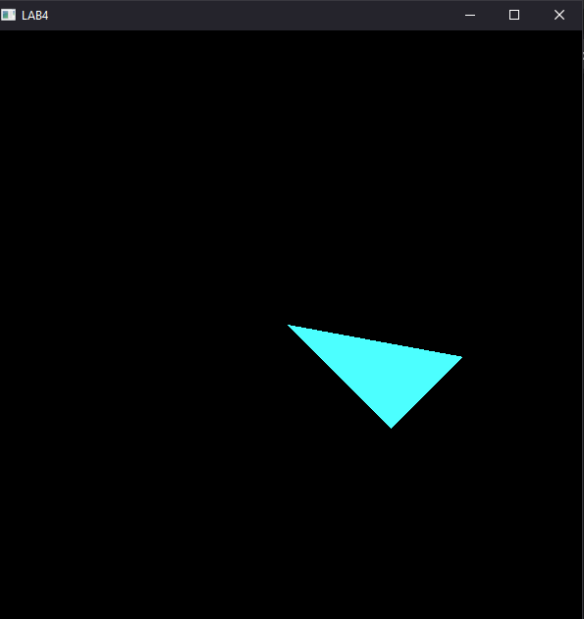

# Chapter 5: 2D Scaling

## 5.1. Scaling Matrix

The scaling matrix is given as:

|  |  |  |  |
| --- | --- | --- | --- |
| Sx | 0 | 0 | 0 |
| 0 | Sy | 0 | 0 |
| 0 | 0 | 0 | 0 |
| 0 | 0 | 0 | 1 |

As it is 2D scaling, the scaling factor across z-aix is set to 0. As discussed earlier, the above row major matrix should be converted in column major matrix by transposing, but as the original matrix and the transposed matrix are identical, above rotation matrix can be used to get required scale.

## 5.2. Source Code

*import* glfw

*import* numpy *as* np

*from* OpenGL.GL *import* *

*from* OpenGL.GL.shaders *import* compileProgram, compileShader

*from* helpers *import* **altList**, **toNVC**

def **window_resize**(*window*, *width*, *height*):

    glViewport(0, 0, *width*, *height*)

RESOLUTION = 800

scaling = np.**array**(

    [

        2.0,  *# D1*

        0.0,

        0.0,

        0.0,

        0.0,

        2.0,  *# D2*

        0.0,

        0.0,

        0.0,

        0.0,

        0.0,  *# D3*

        0.0,

        0.0,

        0.0,

        0.0,

        1.0,

    ],

*dtype*=np.float32,

)

def **main**(*transformation*):

    vertex_src = """

  #version 330

  layout(location=0) in vec3 aPos;

  uniform mat4 transform;

  void main(){

      gl_Position = transform * vec4(aPos,1.0);

      }

  """

    fragment_src = """

  #version 330

  out vec4 FragColor;

  void main(){

      FragColor = vec4(1.0f,0.0f,0.3f,0.0f);

  }

  """

*if* *not* glfw.init():

*raise* Exception("glfw can not be initialized!")

    window = glfw.create_window(RESOLUTION, RESOLUTION, "LAB4", None, None)

*if* *not* window:

        glfw.terminate()

*raise* Exception("glfw window can not be created!")

    glfw.set_window_pos(window, 100, 100)

    glfw.set_window_size_callback(window, **window_resize**)

    glfw.make_context_current(window)

    vertices = [

        -0.27390625,

        0.19890625000000003,

        0,

        -0.27390625,

        -0.4223437499999999,

        0,

        0.34421874999999985,

        -0.4223437499999999,

        0,

    ]

    vertices = np.**array**(vertices, *dtype*=np.float32)

    indices = [1, 2, 3]

    indices = np.**array**(indices, *dtype*=np.uint32)

    shader = compileProgram(

        compileShader(vertex_src, GL_VERTEX_SHADER),

        compileShader(fragment_src, GL_FRAGMENT_SHADER),

    )

    vertex_buffer_object = glGenBuffers(1)

    glBindBuffer(GL_ARRAY_BUFFER, vertex_buffer_object)

    glBufferData(GL_ARRAY_BUFFER, vertices.nbytes, vertices, GL_STREAM_DRAW)

    element_buffer_object = glGenBuffers(1)

    glBindBuffer(GL_ELEMENT_ARRAY_BUFFER, element_buffer_object)

    glBufferData(GL_ELEMENT_ARRAY_BUFFER, indices.nbytes, indices,

                 GL_STREAM_DRAW)

    glEnableVertexAttribArray(0)

    glVertexAttribPointer(0, 3, GL_FLOAT, GL_FALSE, 0, ctypes.c_void_p(0))

    glUseProgram(shader)

    transformation_location = glGetUniformLocation(shader, "transformation")

*while* *not* glfw.window_should_close(window):

        glfw.poll_events()

        glUniformMatrix4fv(transformation_location, 1, GL_FALSE,

*transformation*)

        glDrawElements(GL_TRIANGLES, **len**(indices), GL_UNSIGNED_INT, None)

        glfw.swap_buffers(window)

    glfw.terminate()

**main**(scaling)

## 5.3. Output

### 5.3.1. Original Triangle



### 5.3.2. Scaled Triangle with scaling factor 1.5

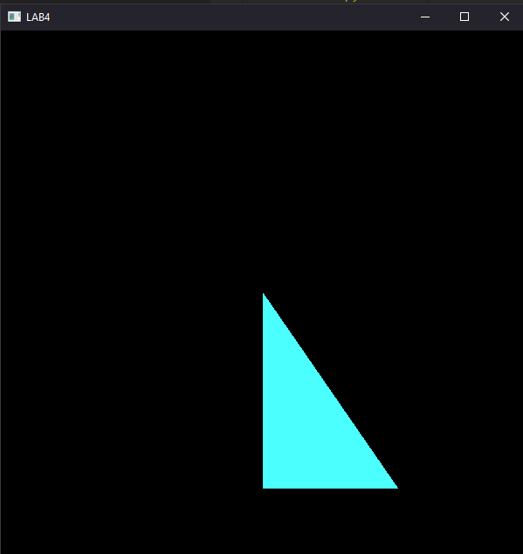

### 5.3.3. Scaled Triangle with Scaling factor 1.5 along x-axis

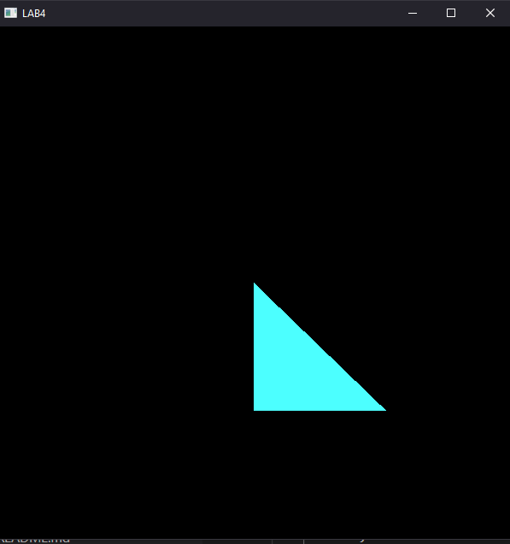

### 5.3.4. Scaled Triangle with Scaling factor 1.5 along y-axis

# Chapter 6: Reflection on 2D Objects

## 6.1. Reflection Matrix

The reflection matris on x-axis is given by:

|  |  |  |  |
| --- | --- | --- | --- |
| 1 | 0 | 0 | 0 |
| 0 | -1 | 0 | 0 |
| 0 | 0 | 0 | 0 |
| 0 | 0 | 0 | 1 |

And, the reflection matrix on y-axis is given by:

|  |  |  |  |
| --- | --- | --- | --- |
| -1 | 0 | 0 | 0 |
| 0 | 1 | 0 | 0 |
| 0 | 0 | 0 | 0 |
| 0 | 0 | 0 | 1 |

The reflection in z axis is set to 0 as it is not required for our two-dimensional triangle. As discussed earlier, the above row major matrix should be converted in column major matrix by transposing, but as the original matrix and the transposed matrix are identical, above rotation matrix can be used to get required scale.

## 6.2. Source Code

*import* glfw

*import* numpy *as* np

*from* OpenGL.GL *import* *

*from* OpenGL.GL.shaders *import* compileProgram, compileShader

*from* helpers *import* **altList**, **toNVC**

def **window_resize**(*window*, *width*, *height*):

    glViewport(0, 0, *width*, *height*)

RESOLUTION = 800

reflection = np.**array**(

    [

        1.0, 0,0.0,0.0,

        0.0,-1.0,0.0,0.0,

        0.0,0.0,0.0, 0.0,

        0.0,0.0,0.0,1.0,

    ],

    np.float32,

)

def **main**(*transformation*):

    vertex_src = """

  #version 330

  layout(location=0) in vec3 aPos;

  uniform mat4 transform;

  void main(){

      gl_Position = transform * vec4(aPos,1.0);

      }

  """

    fragment_src = """

  #version 330

  out vec4 FragColor;

  void main(){

      FragColor = vec4(1.0f,0.0f,0.3f,0.0f);

  }

  """

*if* *not* glfw.init():

*raise* Exception("glfw can not be initialized!")

    window = glfw.create_window(RESOLUTION, RESOLUTION, "LAB4", None, None)

*if* *not* window:

        glfw.terminate()

*raise* Exception("glfw window can not be created!")

    glfw.set_window_pos(window, 100, 100)

    glfw.set_window_size_callback(window, **window_resize**)

    glfw.make_context_current(window)

    vertices = [

        -0.27390625,

        0.19890625000000003,

        0,

        -0.27390625,

        -0.4223437499999999,

        0,

        0.34421874999999985,

        -0.4223437499999999,

        0,

    ]

    vertices = np.**array**(vertices, *dtype*=np.float32)

    indices = [1, 2, 3]

    indices = np.**array**(indices, *dtype*=np.uint32)

    shader = compileProgram(

        compileShader(vertex_src, GL_VERTEX_SHADER),

        compileShader(fragment_src, GL_FRAGMENT_SHADER),

    )

    vertex_buffer_object = glGenBuffers(1)

    glBindBuffer(GL_ARRAY_BUFFER, vertex_buffer_object)

    glBufferData(GL_ARRAY_BUFFER, vertices.nbytes, vertices, GL_STREAM_DRAW)

    element_buffer_object = glGenBuffers(1)

    glBindBuffer(GL_ELEMENT_ARRAY_BUFFER, element_buffer_object)

    glBufferData(GL_ELEMENT_ARRAY_BUFFER, indices.nbytes, indices,

                 GL_STREAM_DRAW)

    glEnableVertexAttribArray(0)

    glVertexAttribPointer(0, 3, GL_FLOAT, GL_FALSE, 0, ctypes.c_void_p(0))

    glUseProgram(shader)

    transformation_location = glGetUniformLocation(shader, "transformation")

*while* *not* glfw.window_should_close(window):

        glfw.poll_events()

        glUniformMatrix4fv(transformation_location, 1, GL_FALSE,

*transformation*)

        glDrawElements(GL_TRIANGLES, **len**(indices), GL_UNSIGNED_INT, None)

        glfw.swap_buffers(window)

    glfw.terminate()

**main**(reflection)

## 6.3. Output

### 6.3.1. Original Triangle



### 6.3.2. Reflection about x-axis

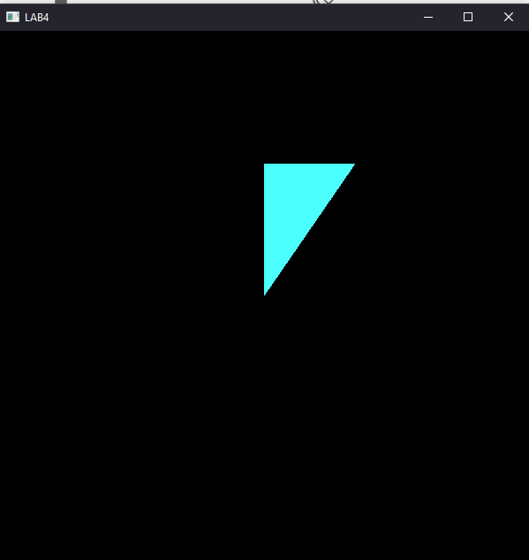

### 6.3.2. Reflection about y-axis

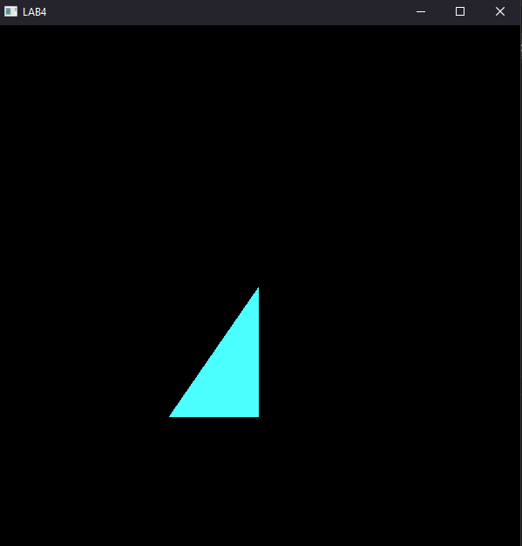

# Chapter 7: 2D Shearing

## 7.1. Shearing Matrix

The shearing matrix on x-axis is given as:

|  |  |  |  |
| --- | --- | --- | --- |
| 1 | 0 | 0 | 0 |
| shx | 1 | 0 | 0 |
| 0 | 0 | 0 | 0 |
| 0 | 0 | 0 | 1 |

And the shearing matrix in y-axis is given as:

|  |  |  |  |
| --- | --- | --- | --- |
| 1 | shy | 0 | 0 |
| 0 | 1 | 0 | 0 |
| 0 | 0 | 0 | 0 |
| 0 | 0 | 0 | 1 |

However, there is one more problem as the vertex shader calculates matrix multiplications in a column major basis but the normal matrix as shown above is a row major matrix. Hence the matrix sent to the GPU is actually transposed to get the following:

|  |  |  |  |
| --- | --- | --- | --- |
| 1 | shx | 0 | 0 |
| 0 | 1 | 0 | 0 |
| 0 | 0 | 0 | 0 |
| 0 | 0 | 0 | 1 |

And in y-axis is given as:

|  |  |  |  |
| --- | --- | --- | --- |
| 1 | 0 | 0 | 0 |
| shy | 1 | 0 | 0 |
| 0 | 0 | 0 | 0 |
| 0 | 0 | 0 | 1 |

## 7.2. Source Code

*import* glfw

*import* numpy *as* np

*from* OpenGL.GL *import* *

*from* OpenGL.GL.shaders *import* compileProgram, compileShader

*from* helpers *import* **altList**, **toNVC**

def **window_resize**(*window*, *width*, *height*):

    glViewport(0, 0, *width*, *height*)

RESOLUTION = 800

shearing = np.**array**(

    [

        1.0,  *# D1*

        0.8,  *# ShearX*

        0.0,

        0.0,

        0.0,  *# ShearY*

        1.0,  *# D2*

        0.0,

        0.0,

        0.0,

        0.0,

        0.0,

        0.0,

        0.0,

        0.0,

        0.0,

        1.0,

    ],

    np.float32,

)

def **main**(*transformation*):

    vertex_src = """

  #version 330

  layout(location=0) in vec3 aPos;

  uniform mat4 transform;

  void main(){

      gl_Position = transform * vec4(aPos,1.0);

      }

  """

    fragment_src = """

  #version 330

  out vec4 FragColor;

  void main(){

      FragColor = vec4(1.0f,0.0f,0.3f,0.0f);

  }

  """

*if* *not* glfw.init():

*raise* Exception("glfw can not be initialized!")

    window = glfw.create_window(RESOLUTION, RESOLUTION, "LAB4", None, None)

*if* *not* window:

        glfw.terminate()

*raise* Exception("glfw window can not be created!")

    glfw.set_window_pos(window, 100, 100)

    glfw.set_window_size_callback(window, **window_resize**)

    glfw.make_context_current(window)

    vertices = [

        -0.27390625,

        0.19890625000000003,

        0,

        -0.27390625,

        -0.4223437499999999,

        0,

        0.34421874999999985,

        -0.4223437499999999,

        0,

    ]

    vertices = np.**array**(vertices, *dtype*=np.float32)

    indices = [1, 2, 3]

    indices = np.**array**(indices, *dtype*=np.uint32)

    shader = compileProgram(

        compileShader(vertex_src, GL_VERTEX_SHADER),

        compileShader(fragment_src, GL_FRAGMENT_SHADER),

    )

    vertex_buffer_object = glGenBuffers(1)

    glBindBuffer(GL_ARRAY_BUFFER, vertex_buffer_object)

    glBufferData(GL_ARRAY_BUFFER, vertices.nbytes, vertices, GL_STREAM_DRAW)

    element_buffer_object = glGenBuffers(1)

    glBindBuffer(GL_ELEMENT_ARRAY_BUFFER, element_buffer_object)

    glBufferData(GL_ELEMENT_ARRAY_BUFFER, indices.nbytes, indices,

                 GL_STREAM_DRAW)

    glEnableVertexAttribArray(0)

    glVertexAttribPointer(0, 3, GL_FLOAT, GL_FALSE, 0, ctypes.c_void_p(0))

    glUseProgram(shader)

    transformation_location = glGetUniformLocation(shader, "transformation")

*while* *not* glfw.window_should_close(window):

        glfw.poll_events()

        glUniformMatrix4fv(transformation_location, 1, GL_FALSE,

*transformation*)

        glDrawElements(GL_TRIANGLES, **len**(indices), GL_UNSIGNED_INT, None)

        glfw.swap_buffers(window)

    glfw.terminate()

**main**(shearing)

## 7.3. Output

### 7.3.1. Original Triangle



### 7.3.2. Triangle sheared on x-axis

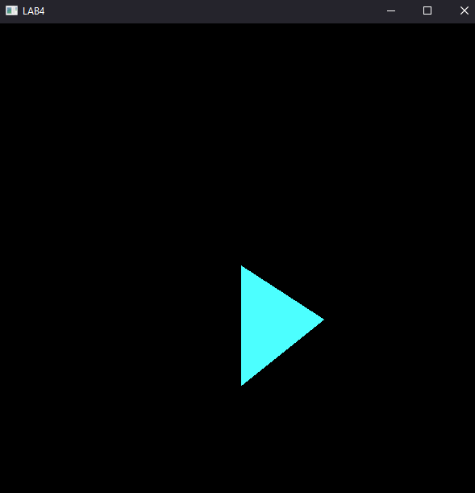

### 7.3.3. Triangle sheared along y-axis

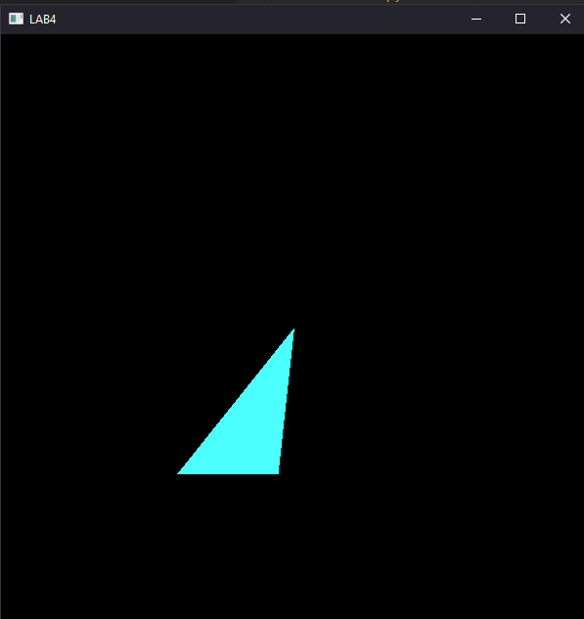

# Chapter 8: Conclusion

In this Lab work, various transformation matrix was used to achieve various transformations on 2D objects. The transformations that we implemented are: translations, reflection, rotation, scaling and shearing. The transformation matrix that we normally use cannot be directly sent to the program as GPU uses column major format of matrices, so the transposed matrix has been sent to the program.

The desired transformation operation is provided to the program as parameter like:



And the program is provided with 4 x 4 transposed matrix using is stored using NumPy array.

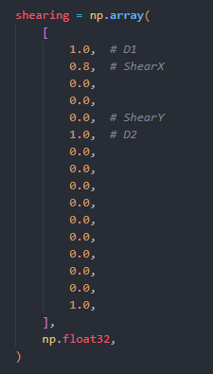

Also, the vertices of our original triangle was also defined as:

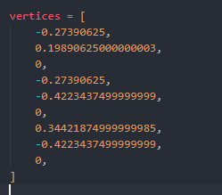

Furthermore, a uniform matrix transformation shader had been made, and the location of which was stored under transformation_location as:

transformation_location = glGetUniformLocation(shader, "transformation")

Finally, using the glUniformMatrix4fv matrix was transformed and GL_TRIANGLES was made by using glDrawElements.

 glUniformMatrix4fv(transformation_location, 1, GL_FALSE,

*transformation*)